Name: MITHUN MARAGIRI

Course: EE450

Session #: 2

Assignment: OPNET Switched LAN

**ABSTRACT**

The purpose of this report is to discuss the laboratory assignment for the course EE-450 Introduction to Computer Networks. The assignment is to simulate Switched LAN environment with real-time networks and protocols. The labs have been deployed in Riverbed Modeler Academic simulation environment. The simulation in this lab will help examine the performance of different implementation of LAN using Hubs and Switches.

The assignment consists of simulation of 4 scenarios: Only Hub, HubAndSwitch, Only Switch, SwitchAndSwitch topologies. The analysis of the experiment results are done for the following criteria: Delay, Traffic Received (Packets/sec), Traffic Sent (Packets/Sec) and Collision Count.

**INTRODUCTION**

Riverbed Modeler Academic Edition offers all the tools for network model design, simulation and analysis of the experiment results. Riverbed Modeler can simulate a wide variety of different networks. The laboratory has been designed to simulate Switched Local Area Network. Through this lab, we get to learn how to use Rapid Configuration Tool, the different options available while setting up a network, the simulation parameters, comparing the results from different scenarios, the design of network simulation for performance evaluation.

**Hub:** It is a physical layer device. It will forward the incoming frames to all the connected hosts.

**Switch:** It is a data link layer device. It will forward the incoming frame only to desired destination host.

A switch is a device with several inputs and outputs leading to and from the hosts that the switch interconnects.

**IMPLEMENTATION**

***Scenario 1: Only Hub***

* Create a new project and new scenario and give it a name OnlyHub.
* Setup the initial topology and Network scale list as office network.
* Select Star Topology in the Rapid Configuration drop down menu.
* Select Ethernet Model and set the values: Center Node Model = Ethernet16_Hub, Periphery Node Model = Ethernet_station, Link Model =10BaseT and Number = 16.
* This will create a Hub which can support up to 16 ethernet connections and set each of these 16 connections to an ethernet station using 10BaseT links.
* **10BaseT**: The 10 represents that the link can support 10 Mbps transmission speed, Base refers to baseband signalling which means only ethernet signals are carried on the medium and the T stands for twisted pair wire.

The network configured in the above described way will look like this

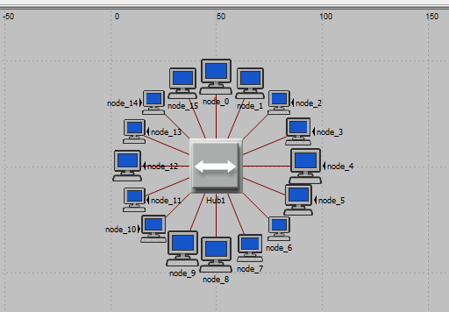

* Set the traffic generation parameters for all the nodes connected to the HUB1.
* ON state Time = exponential (100), OFF state time = exponential (0.000001). This means application generates traffic only in ON state.
* Set the packet generation parameters Interarrival Time = exponential (0.02) seconds and Packet size = constant 1500 bytes.
* Exponential means that the value is chosen based on exponential distribution. For instance Interarrival Time = exponential (0.02) means the interarrival time is chosen randomly from exponential distribution with an average value of 0.02 seconds. That is on average 50 packets will be generated per second.
* Packets size sets the size of the packets and constant means that all the packets are of same size.
* Now choose the global statistics- Delay, Traffic Received (Packets/Sec) and Traffic Sent (Packets/Sec), also choose Nodal statistic of Collision Count.
* Run the simulation for 2 minutes.

Results of the experiment:

Delay Traffic Received

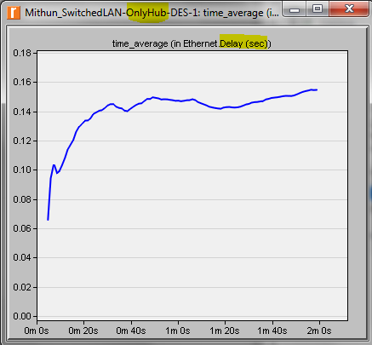 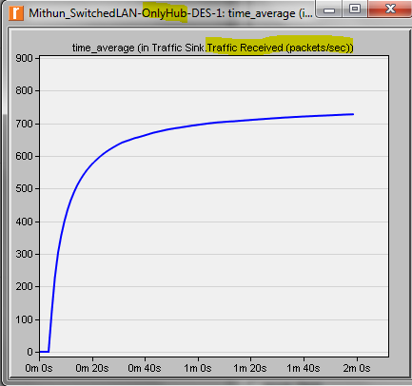

Traffic Sent Collision Count

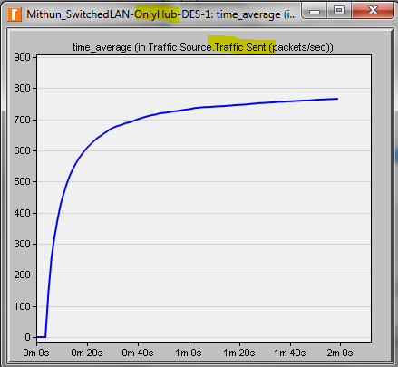 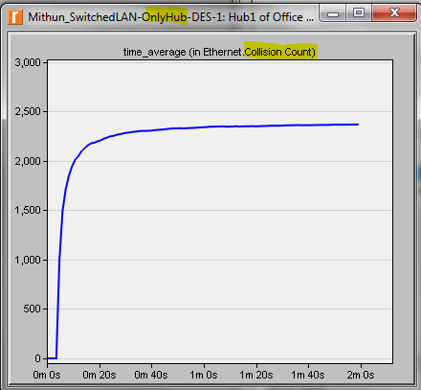

***Scenario 2: HubAndSwitch***

* Duplicate the above scenario.
* Add another ethernet16_Hub and name it Hub2, add an ethernet16_switch and name it Switch.
* Rearrange the ethernet stations such that stations 8 thru 15 are in Hub1 and stations 0 thru 7 are in Hub2.
* Use a 10BaseT link to connect hub to switch, ethernet station to hub.

The topology will look like this

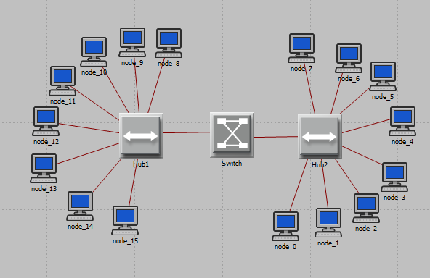

* Run the simulation

Results of both the scenarios combined: OnlyHub and HubAndSwitch

Delay Traffic Received

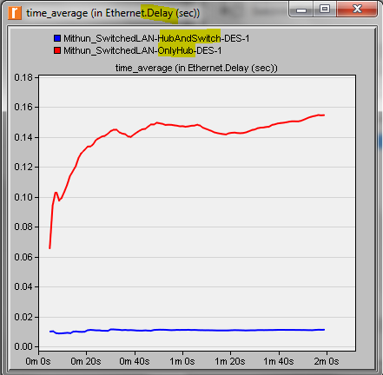 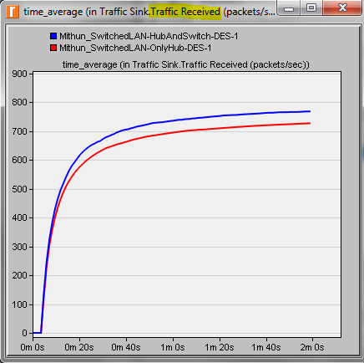

* It is seen that the delay is very much less in HubAndSwitch LAN compared to OnlyHub LAN. This is because of the possible collisions of the frames in Hub LAN
* The throughput in HubAndSwitch LAN is more than OnlyHub LAN. This is because in switch based LAN the frame will not collide with other frames, the frame will be delivered to appropriate destination only. However in Hub based LAN the frames collide and hence incur delay.

Traffic Sent Collision Count

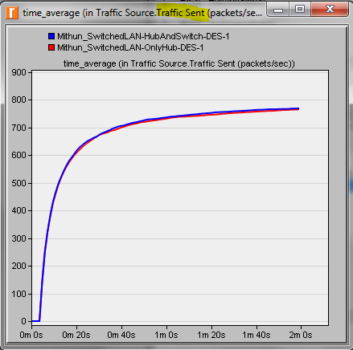 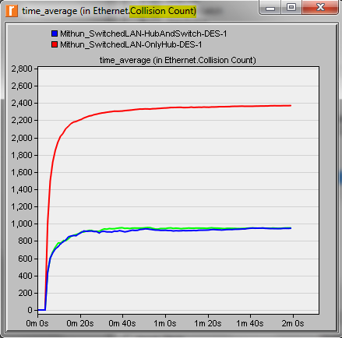

* The traffic sent is almost the same in both LANs.
* It is noticeable that with the use of switch between 2 Hubs the collision count is reduced by one third value compared to OnlyHub LAN.

***Scenario 3: OnlySwitch***

* Duplicate scenario 1 and change the ethernet16_hub to ethernet16_switch.

The topology will look like this

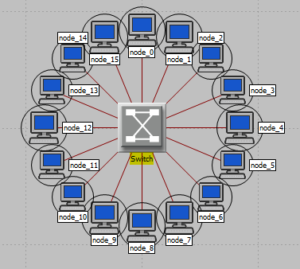

Run the Simulation for 2 minutes.

Results of the experiment in comparison with Scenario 1 with hub

Delay Traffic Received

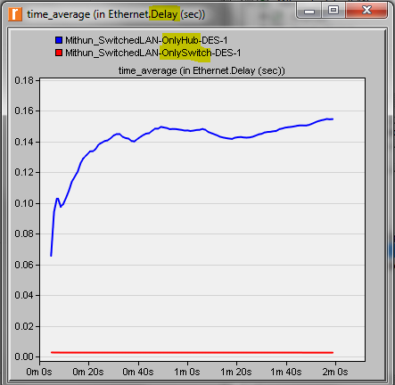 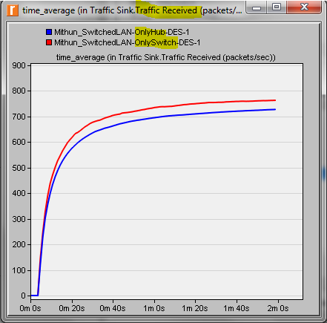

* The delay in OnlySwitch LAN is very much less than OnlyHub LAN. This is because of the lack of collision and the frames will be delivered to desired destination in switched LAN.
* The traffic received in LAN with switch is more than LAN with hub. This is because with switch full duplex communication is possible, sending and receiving data can be done independently on different channels without sharing the bandwidth hence leads to greater throughput and the collision in Hub LAN will reduce the throughput.

Traffic Sent Collision Count

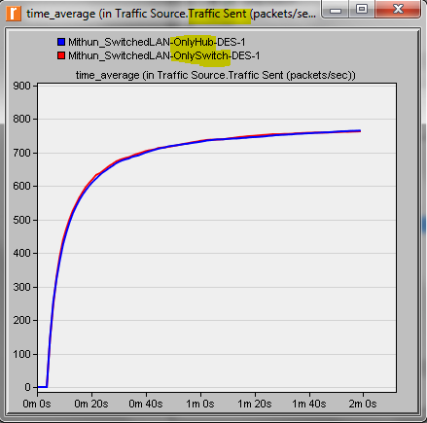 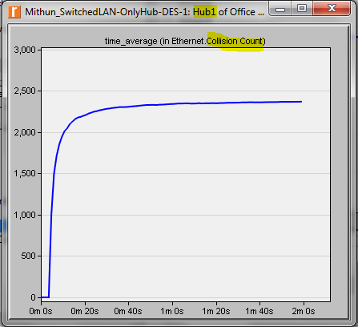

* The traffic sent is almost the same for both the LANs.
* There is no collision count for OnlySwitch scenario since there will not be any collision in switched LAN

***Scenario 4: SwitchAndSwitch***

* Duplicate scenario 2. Replace both the ethernet16_hub with ethernet16_switch. Remove the previous switch which was connecting the 2 hubs.
* Use 10BaseT links to connect the 2 switches.

The topology will look like this

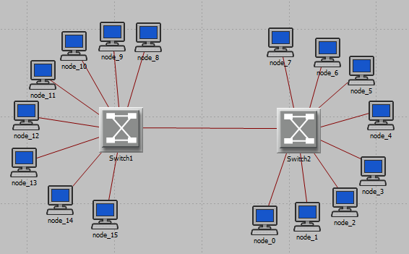

* Run the simulation for 2 minutes

Results of the experiment compared with all 3 other scenarios

Delay Traffic Received

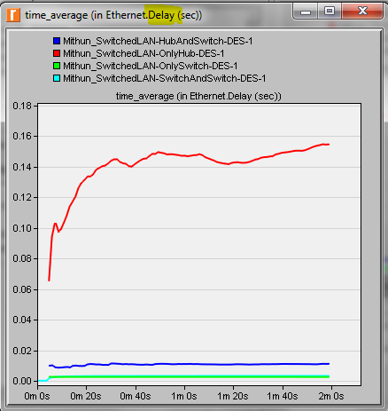 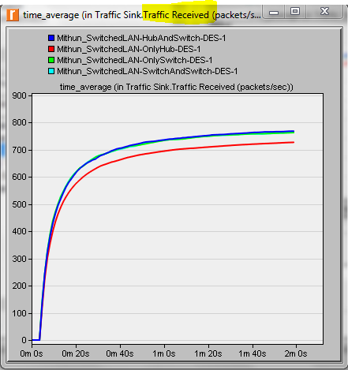

* The OnlyHub LAN which doesn’t have any switch has the highest delay. The LANs with Switch has considerably less delay. This is because of the lack of collision and the frames will be delivered to desired destination in switched LAN.
* We can also note that the delay is even reduced when the Hubs are removed from the switched LAN. That is scenario 4 in green colour. Since the LAN has only switches there is no delay since here is no collision or random wait for the host before sending frame. Host can send at its will.
* The traffic received in LAN with switch is more than LAN with hub. This is because with switch full duplex communication is possible, sending and receiving data can be done independently on different channels without sharing the bandwidth hence leads to greater throughput and the collision in Hub LAN will also add in reducing the throughput.

Traffic Sent Collision Count

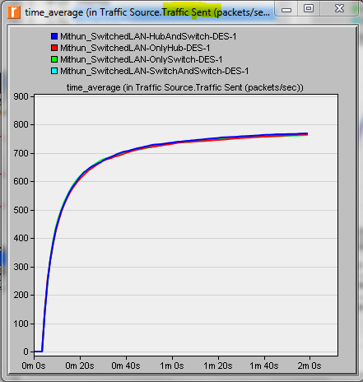 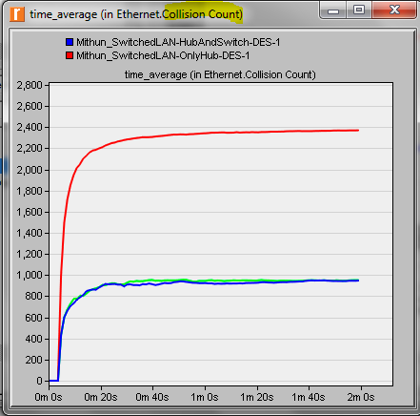

* The traffic sent is almost the same in all the LANs
* It can be noticed that the LAN with OnlyHub has the highest collision count. The collision count is reduced considerably for HubAndSwitch LAN. Also notice that the graph doesn’t have the collision count for scenario 3 – OnlySwitch and scenario 4 – SwitchAndSwitch this is because of the fact that there are no collisions in Switch based LANs.

**EXERCISE**

1. Explain why adding a switch makes the network perform better in terms of throughput and delay?

Ans: Every node in a Hub Based network should wait for the opportunity to transmit in order to avoid collisions. The latency can increase as you add more nodes to the network. Ethernet uses CSMA/CD to detect collision in shared network in Hub based LAN. If a node send out a frame and collision occurs then the node wait a random amount of time and send the frame again. This adds to the considerable delay in the Hub based LANs.

Every device that connect to HUB share the bandwidth but a device that connects to switch port has the full bandwidth alone. Switches support full duplex communication, separate conductors are used to send and receive data. The nodes can transmit at will and those nodes are the only devices with the potential to access the medium.

Switches divide the network into several dedicated channels independent from each other. These independent data paths increase throughput capacity of a switch. However in the HUB LAN the nodes share the common bandwidth and the possibility of collision is more hence the throughput is less in Hub LAN.

 

The red line is the case of OnlyHub. We can notice that the delay is considerably more and also the throughput is less than the LAN which has Switch in the network.

1. We analyzed the collision count of hubs. Can you analyze collision count of the switches?

Ans: There are no collisions in Switches hence the results couldn’t display the collision count for scenario 3 and 4.

In the switched network, nodes only communicate with the switch and never directly with each other. The network allows separate lane for traffic that flows in each direction. Separate conductors are used to send and receive data. If two nodes wish to send data at the same time, then switch will store the frames in the buffer and will address each node separately, that way there will not be any collisions.



The collision count in the above graph is because of the presence of HUB. You can also notice that the collision count is reduced when a switch is used between 2 hubs.

1. Create two new scenarios. The first new scenario is the same as the OnlyHub scenario with the hub replaced by a switch. The second new scenario is the same as the HubAndSwitch scenario with both hubs replaced by two switches, the old switch removed, and the two switches you just added together connected with a 10BaseT link. Compare the performance of the four scenarios in terms of delay, throughput, and collision count. Analyze the results.

Ans: These 2 scenarios are addressed in Scenario 3 and Scenario 4. The comparison of the performance is also included along with the graphs.

**RESULTS**

We have studied the 4 cases: Ethernet with OnlyHub, Ethernet with HubAndSwitch, Ethernet with OnlySwitch and Ethernet with SwitchAndSwitch. The results shown in the screenshots throughout the report demonstrate that although the traffic sent is same the traffic received has improved in the cases where Switch is used. The scenarios which include switch makes network perform better in terms of delay and throughput characteristics.

The use of switch makes it possible to reduce the collisions on the network. The delay in the Hub Based LAN is more compared to switch based LAN; also throughput in hub LAN is less compared to Switched LAN

**Riverbed Modeler Experience**

The tool is very much user friendly and has easy to use graphical user interface. The assignment description document has detailed explanation about the configuration and the procedure for conducting the lab. The usage to the tool gave an understanding of how to set up a switched LAN, the various components needed to setup the LAN, the performance measures for each of these scenarios. The installation of the tool is also very simple and straightforward. The tool is scalable to great extent. If we want to update the network scenario we can do it without rebuilding entire thing from scratch. OPNET modeller lets us analyze realistic simulated networks to compare the impact of different technology designs on end to end behaviour.